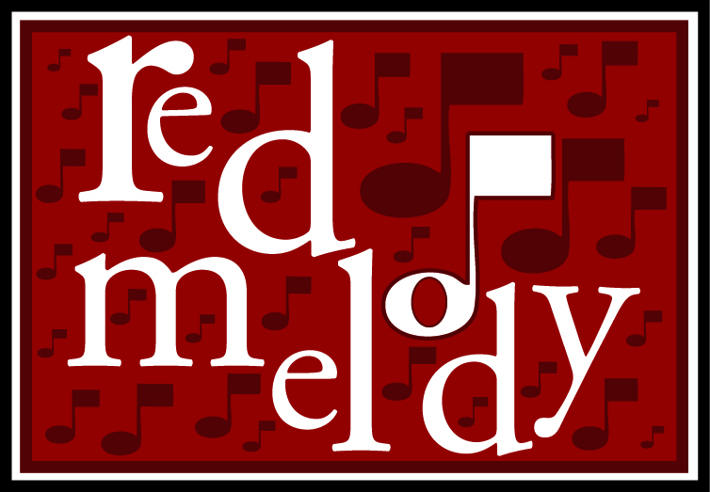 Mini Red Melody: A two week course emphasizing melody and staff reading

Scope and Sequence

 | Singing | Staff reading | Solfeggio | Classical Form
Lesson 1 | Use bells to play a minor 3rd.  Use bells to play a melodic ostinato. | Introduce high and low on staff | Introduce major scale with solfeggio syllables and hand signs  Introduce MRD cadence pattern | Introduce “Argonnaise” from Carmen in puppet show venue. Introduce sections and themes.
Lesson 2 | Use audiation to internalize melody. | Introduce lines and spaces on the staff. | Audiate MRD. | Perform show to internalize themes
Lesson 3 | Play major scale on bells.  Match pitch. | Introduce notation of major scale and steps. | Play major scale on bells. | Hear themes that move up, themes that move down.
Lesson 4 | Sing harmony using ostinato.  Correctly imitate pitch patterns. | Introduce ordinal counting of lines and spaces. Introduce MRD notation | Introduce MRD notation. | Recognize individual melodic themes.
Lesson 5 | Distinguish up and down by sound. | Introduce SSD notation | Introduce SSD | Recognize individual melodic themes.
Lesson 6 | Use round to sing harmony. | Play MRD and SSD on bells | Imitate solfeggio patterns | Place themes in order.
Lesson 7 | Distinguish between MRD and SSD | Identify staff position of notes. | Distinguish between MRD and SSD | Identify themes moving up or down
Lesson 8 | Review MRD, SSD, harmony and pitch matching. | Review steps, major scale, MRD and SSD notation | Review major scale, MRD, SSD | Review theme differentiation, theme repeats, patterns
Lesson 9 | Sing ostinato to produce harmony | Review staff position | Play solfeggio-based ostinato on bells | Review order of themes.
Lesson 10 | Sing in harmony, sing major scale, sing MRD and SSD, imitate pitch patterns. | Play bells from staff notation. Including MRD, SSD, major scale, steps. | Sing and play major scale, MRD, SSD, with hand signs and syllables. | Perform Show, demonstrating knowledge of themes, motives and form.

Materials Fee: $35. for CD and tone bells set.
Tuition: $50. (variable)
Royalty: $5. per student

